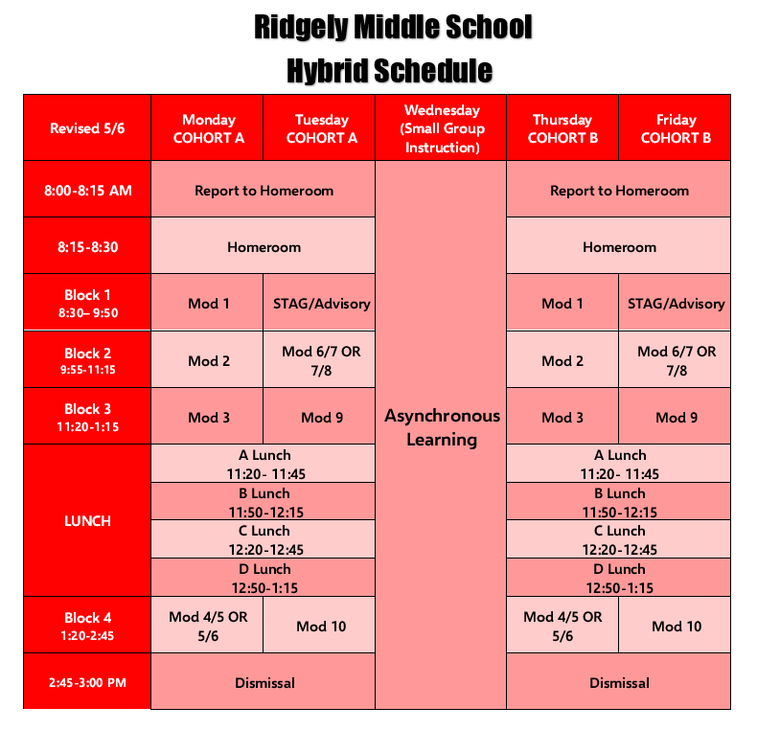
Monday and Thursday. | Tuesday and Friday
- Grade 6 PE will populate D lunch 4 classes on Monday 3 classes on Thursday  - Grade 7 Science Houchens and Sparenberg will populate D lunch.  - Grade 8 Science Kephart, Wilson, and Gerken will populate D lunch. | - Grade 6 Science, Wilkens and Kimball will populate D lunch.  - Grade 7 Science, Houchens and Sparenberg will populate D lunch.  - Grade 8 PE will populate D lunch 4 classes on Tuesday and 3 classes on Friday.
Dismiss to lunch:
A Lunch- 11:15 (w/backpacks)
B Lunch- 11:45
C Lunch- 12:15
D Lunch-12:45 (w/backpacks)

